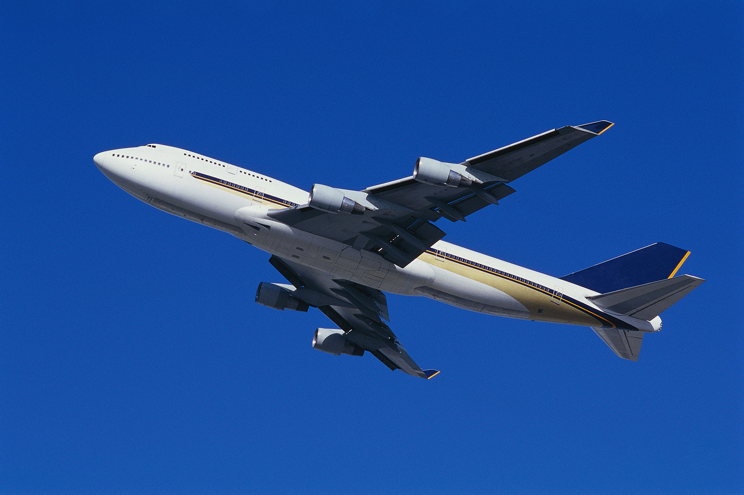
PHYSIOLOGICAL ASPECTS OF FLIGHT

Physiological Aspects of Flight is a basic text discussing all facets of human physiological response to atmospheric and spatial flight. This book fills a gap in the literature related to the understanding of the change in the physiological state of humans during flight. It is a ready source of reference for:
- Students preparing for a career in aviation
- Students of physiology
- Pilots land flight crews
- Ground and support personnel

